This is Sean Cloyd’s Reddit Clone project (named Peruser, a word for a person who reads). It mimics in many ways what Reddit can do, such as allowing users to post information, news, or general topics. It also allows interaction through the use of a simple reply structure.

NOTE: settings file is located in Reddit Clone/utils/settings.php. This contains password and username to the database, usernames to accounts on the site, etc. These changes are global across the entirety of the website.

HUB features:

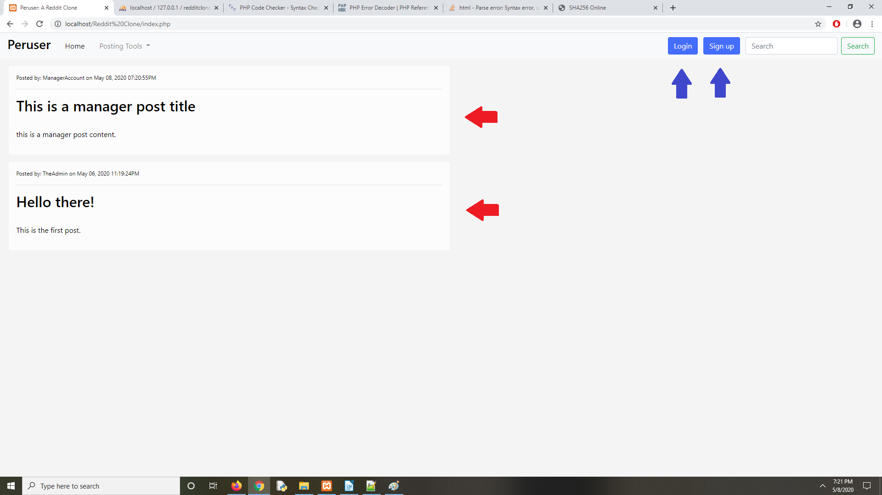

This is the main hub, the home page. It lists the 10 most recent posts (only 10, since if the database were filled up, it would clutter the page). The login/signup links are viewable here, as well as in the rest of the site.

You can highlight and select posts, which will open up the main post area/comment section.

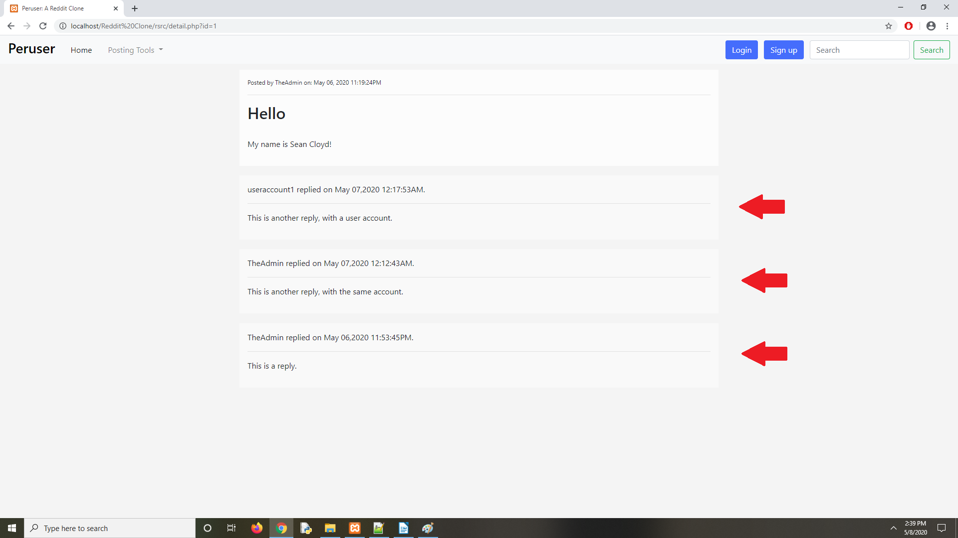

The areas highlighted with red arrows are replies. The main post is shown above these. To comment in these sections, you need to be logged in with a registered account. To login, you click on the blue login button in the navbar. For now, we’ll login as TheAdmin (the default test-account). The password is: password1234 (this is listed in settings.php, under utils/settings.php in the root folder).

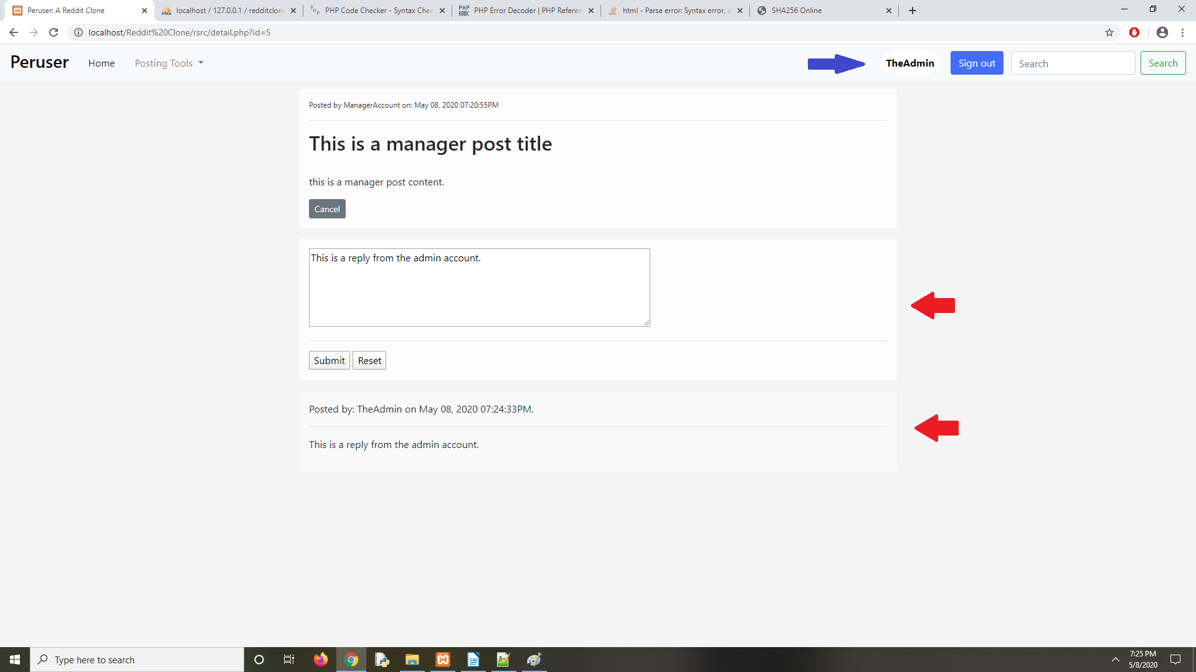

Upon logging in (the blue arrow is pointing to the user we’re currently logged into), you’ll see in the lower left-hand corner of the post that there is a new button named “Reply”. Clicking this button will reveal a form where you can reply to the post beneath the same.

Upon submitting the form, a jQuery procedure will intercept the submission, and perform an asynchronous action (in other words, send the reply data, along with user information such as id). A script named replyHandle.php then processes and stores this data in the database.

Also, upon submit, a segment of jQuery will append the new post for you to see to the end of the list of replies. The replies won’t be reordered by date until a refresh of the page.

Signup/Login/Signout features:
These are relatively simple. All of these features are embedded into the navbar for easy access as blue buttons at the top right, and are updated based on whether you’re logged in or not.

Special Privilege features:
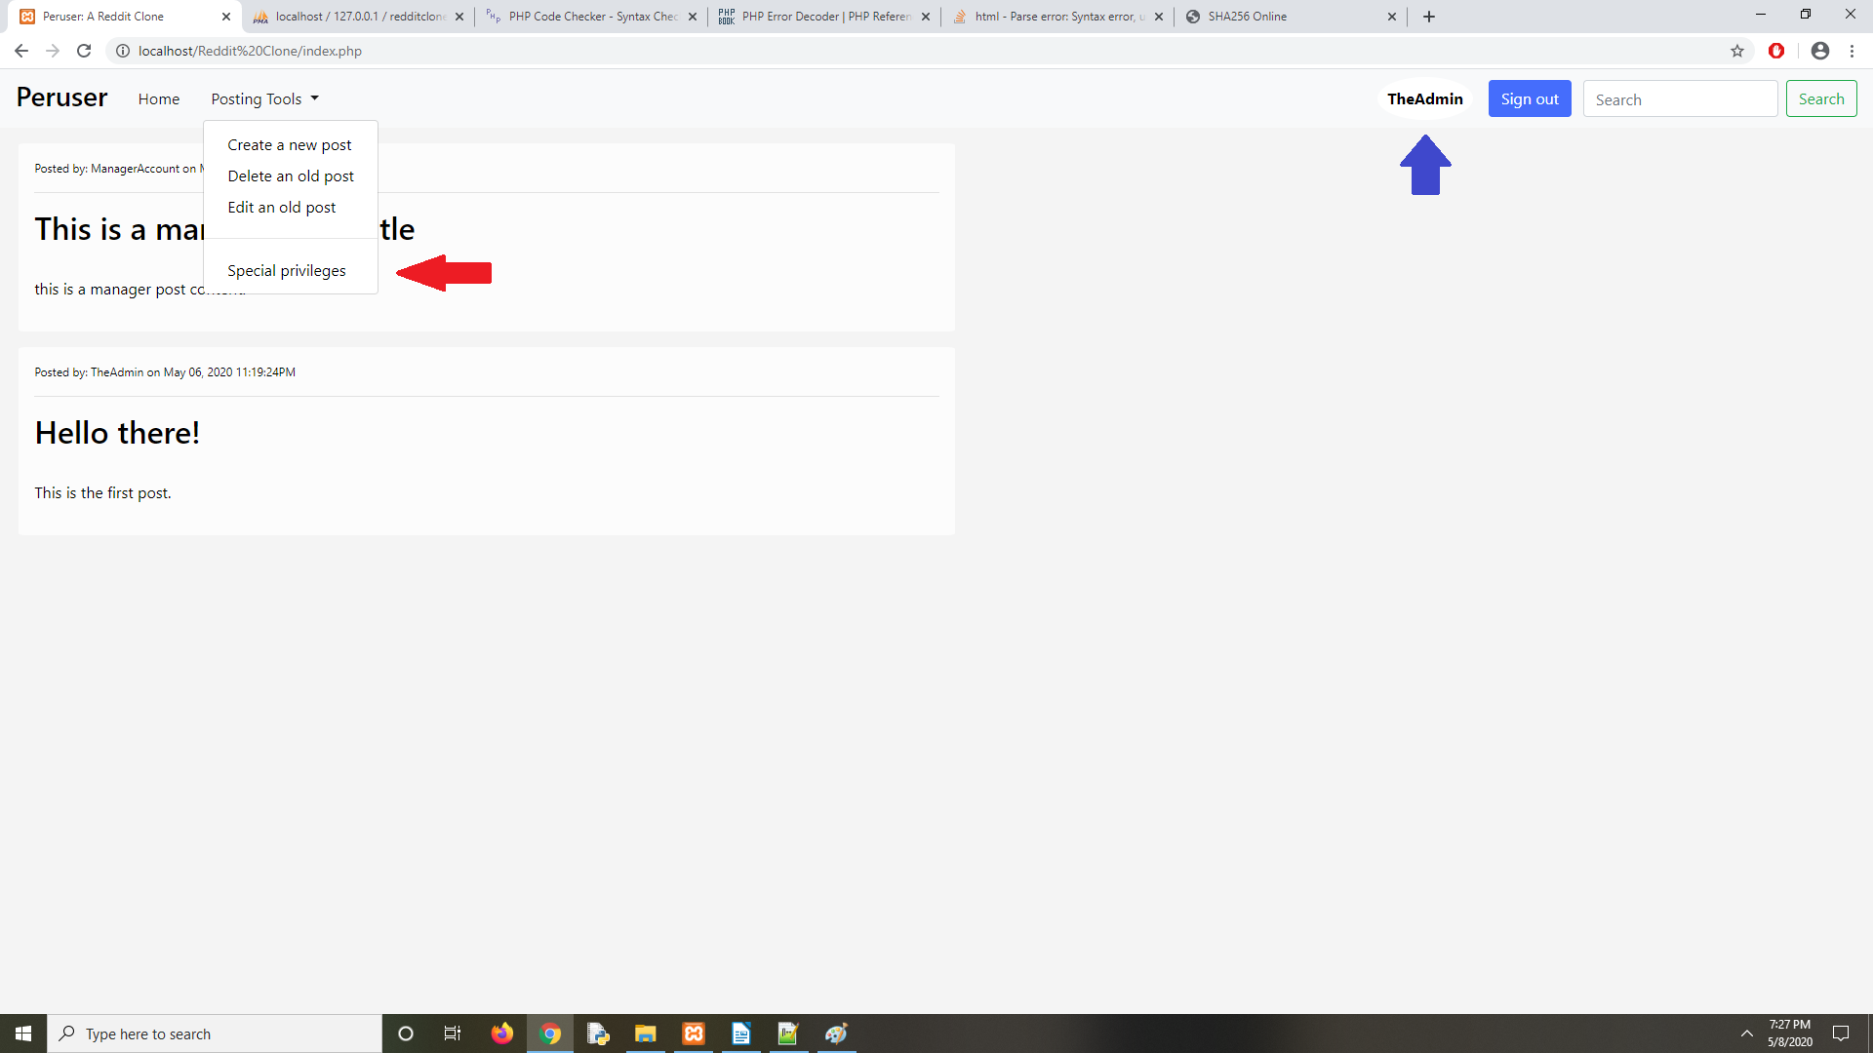
These features are enabled whenever you’re logged in as an admin or manager. Access to these features are under the Posting Tools drop-down. In this image, I’m logged in as TheAdmin.

Clicking on this link leads to a new page. If you’re logged in with Manager, it will direct you to a page allowing post modifications, omitting the User Manager. In admin mode, however, you can select between the User Manager, and the Post Manger.

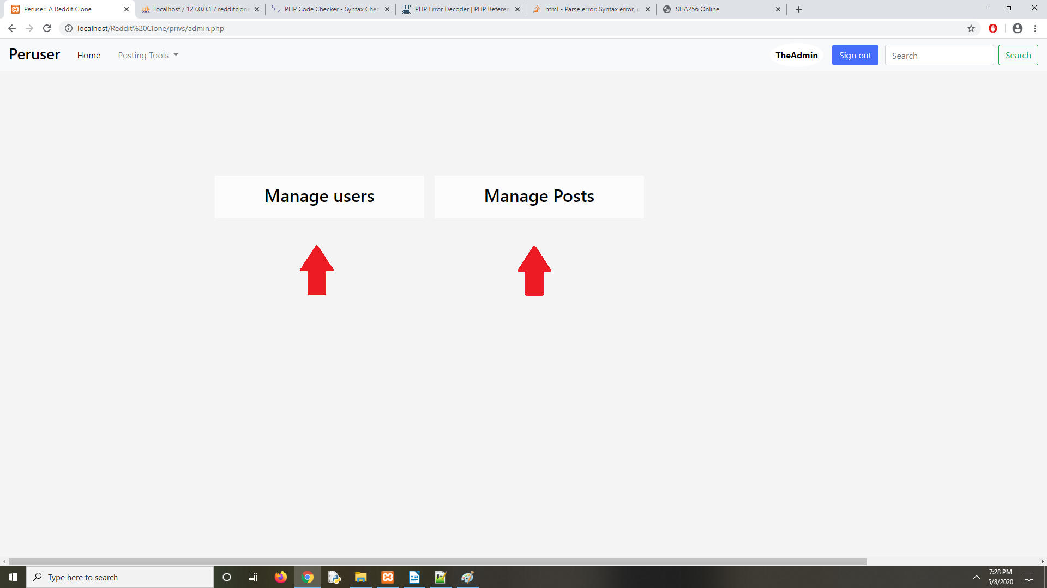
Selecting Manage users takes you to a page where you can search and modify user accounts.

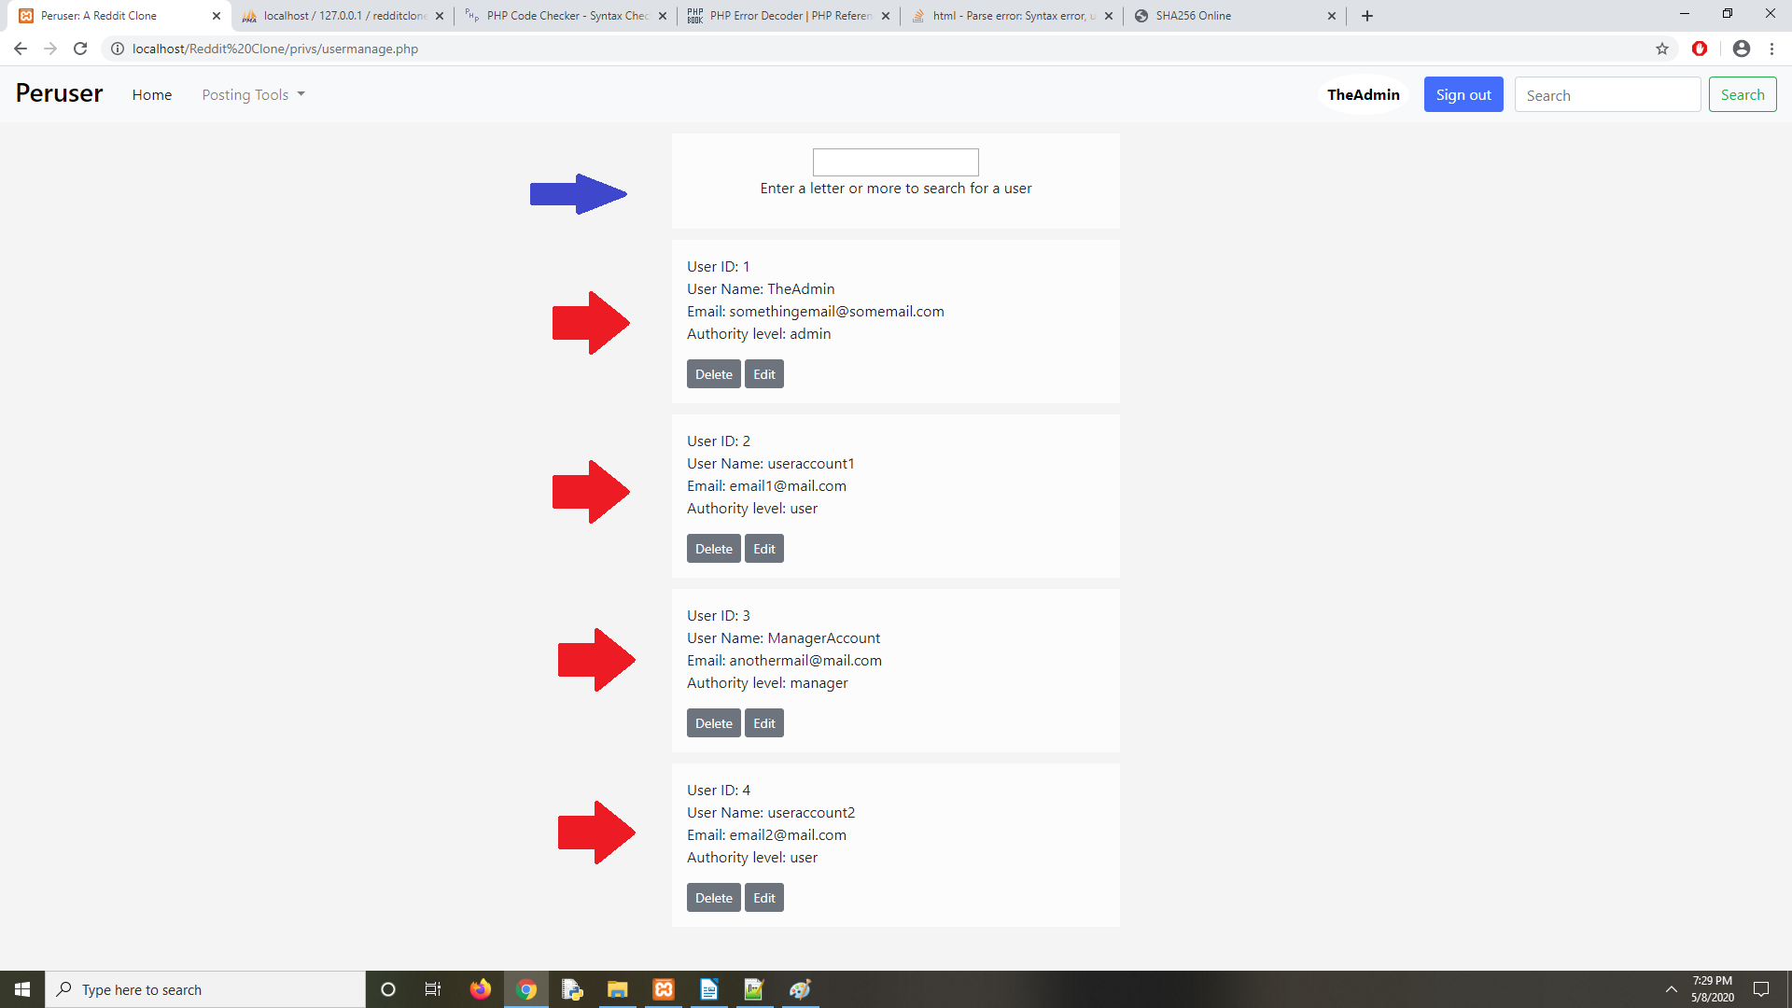
The element highlighted with the blue arrow is the search bar. It uses a simple MySQL query that searches for text containing what you type in. Clicking the delete button will immediately delete the item. Selecting edit will take you to an edit form to change account data.

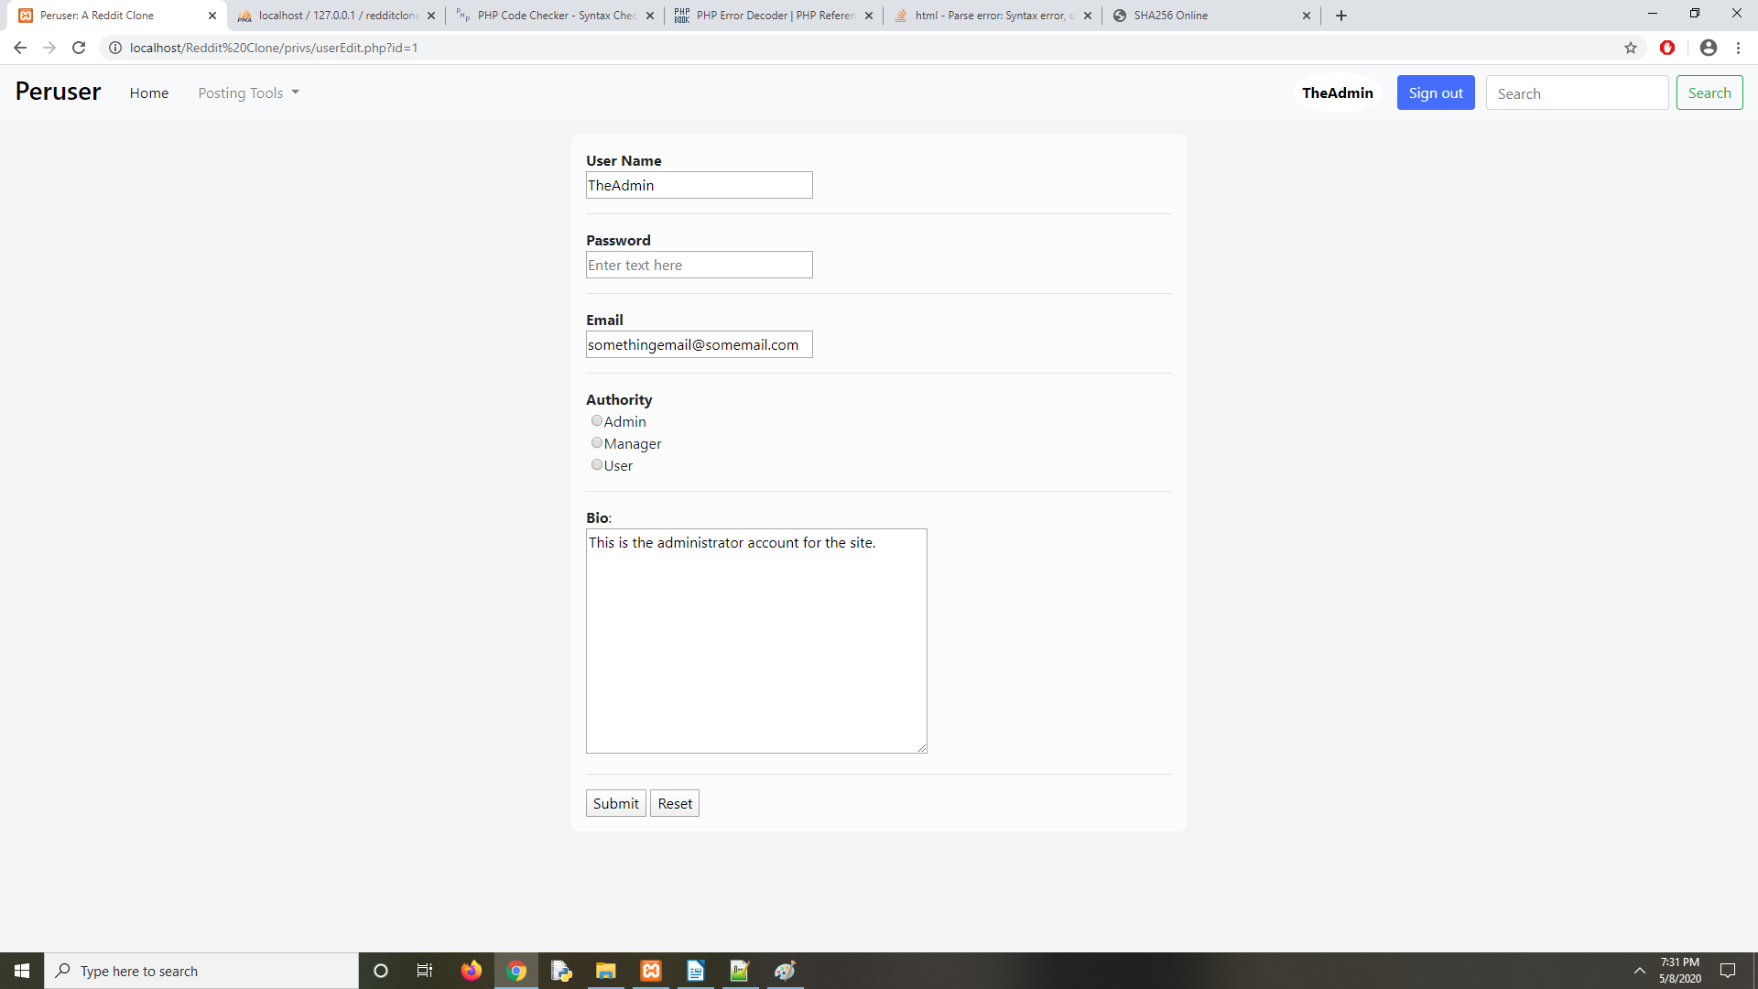
Post manager is similar in structure, with the same utilities, except modified for posts.

Create/Edit/Delete features:

These are located under the Post Tools drop-down. This is available for all registered users, regardless of type. Clicking the create option will take you to a post creation form. In the image, useraccount1 is being used. This can be done with any other user type.

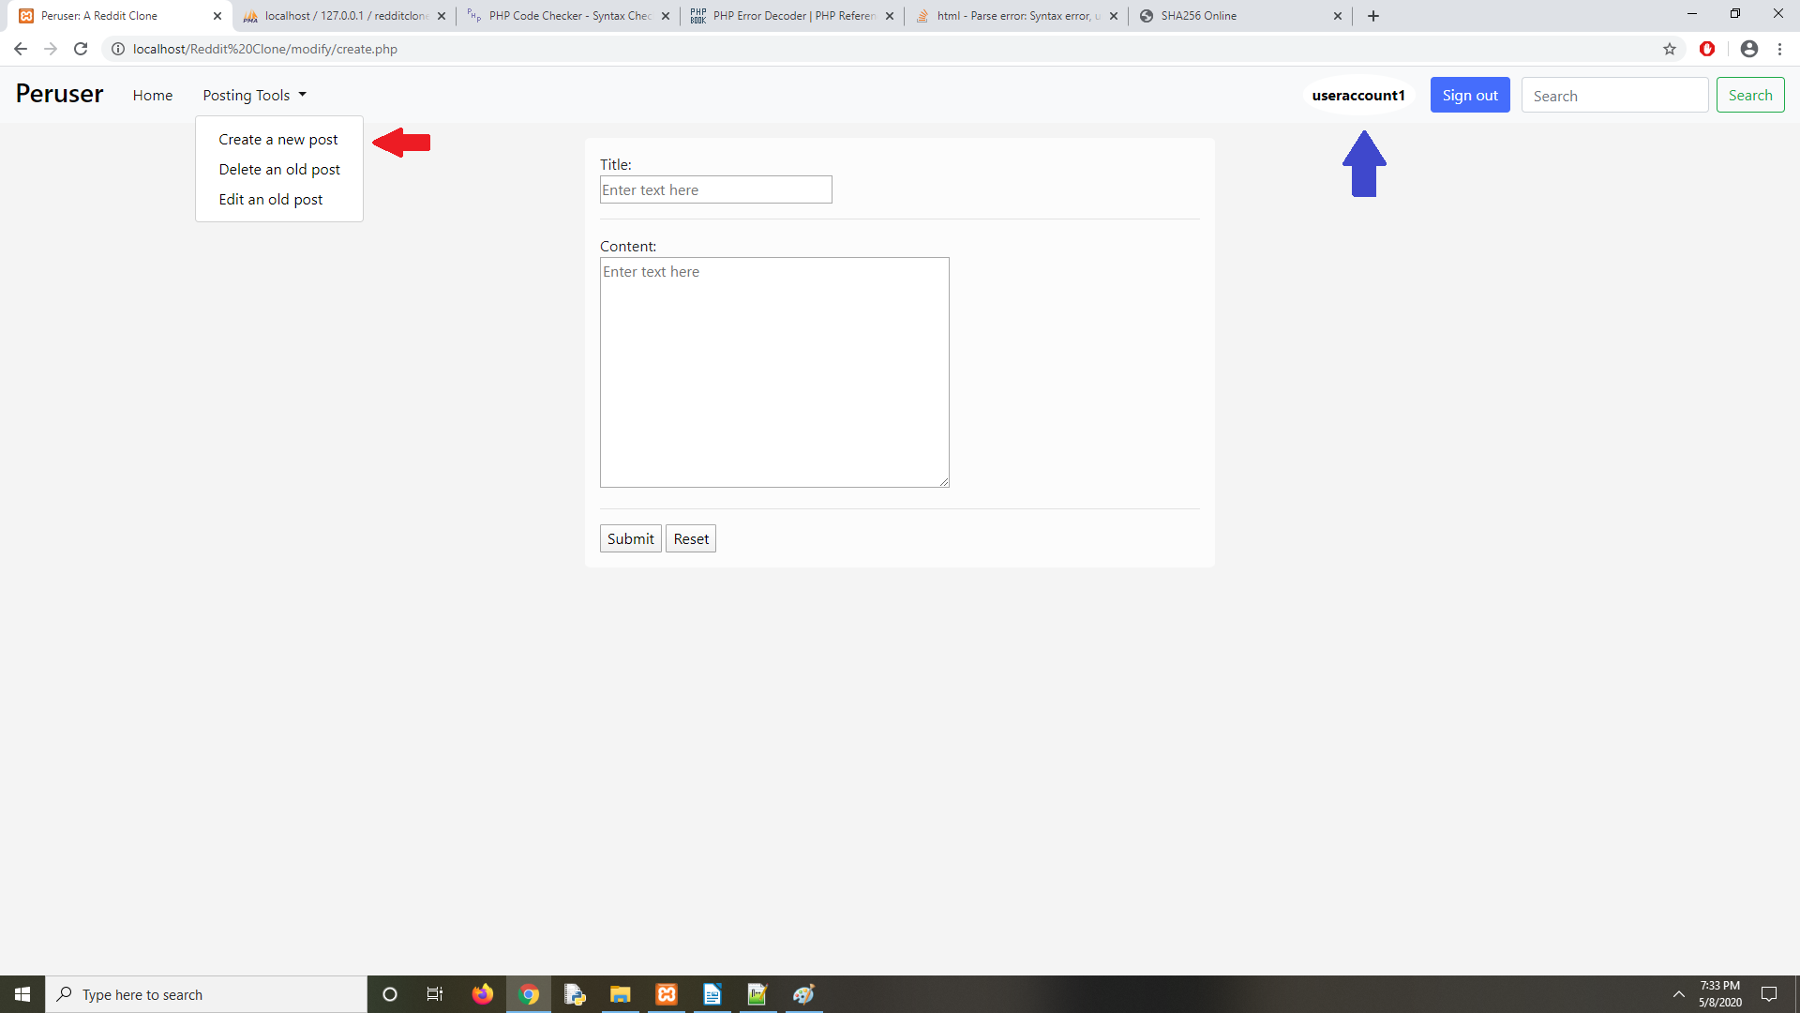

Clicking on the Edit link will take you to edit selection. This will display all of your past posts. Selecting one will take you to it’s respective edit form.
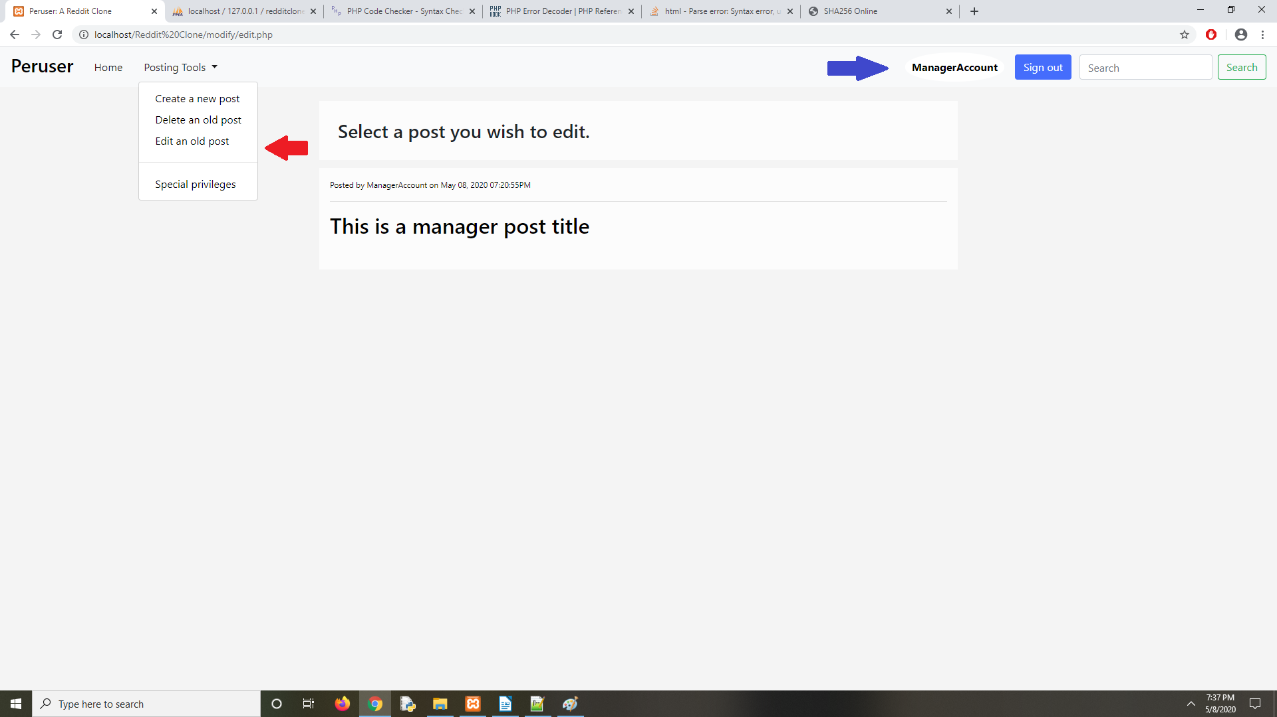
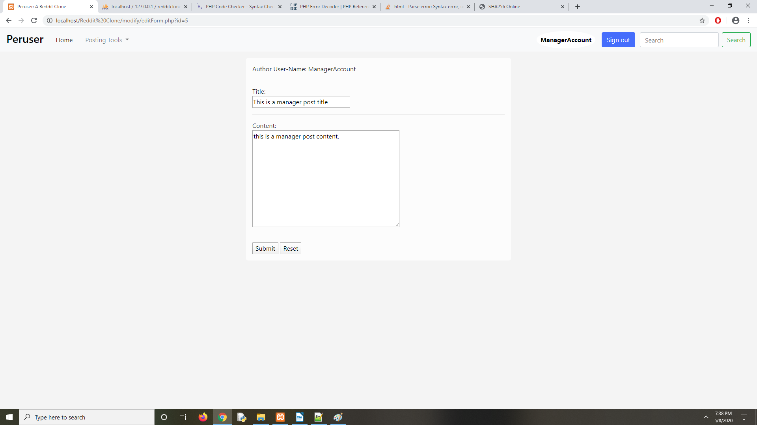
The edit form:

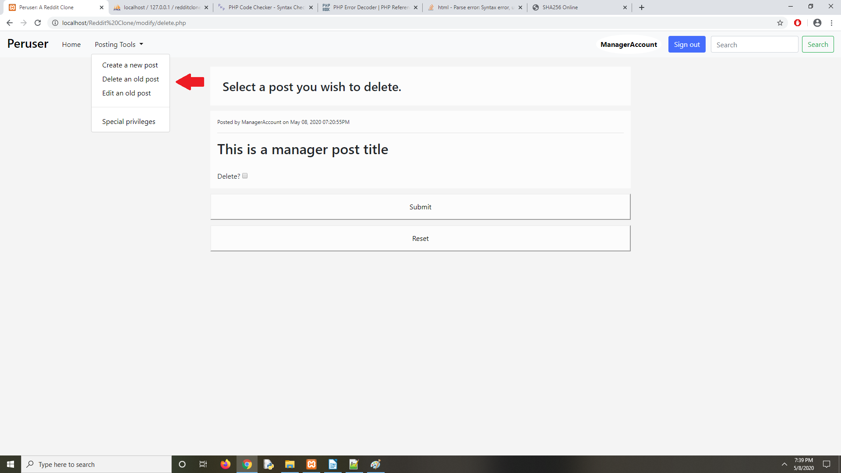
Clicking the Delete link will take you to a similar page, containing all the past posts you’ve made, with selection checkboxes to allow multiples deletions. Upon pressing the submit button, the server will process the request, and delete the post. This will also delete all replies associated to it in the reply table.

To verify that the changes you make through these features work, go to the home page by either 1) clicking the name Peruser at the top left, or 2) clicking the home button. You should see the changes in the posts.

Bio

The final feature of this project involves the personal page of every user. This section wasn’t developed as fully as I would have liked, since I had a few problems with database corruption, which left me with shortened time. Clicking the user name in the navbar takes you to the personal bio of the currently logged user. If the user attempts to go to the page containing a user’s data, they will not see a bio edit form in the center, only the bio text. This means that only the owner of this page can edit it (or through the use of the Special privileges section covered earlier.
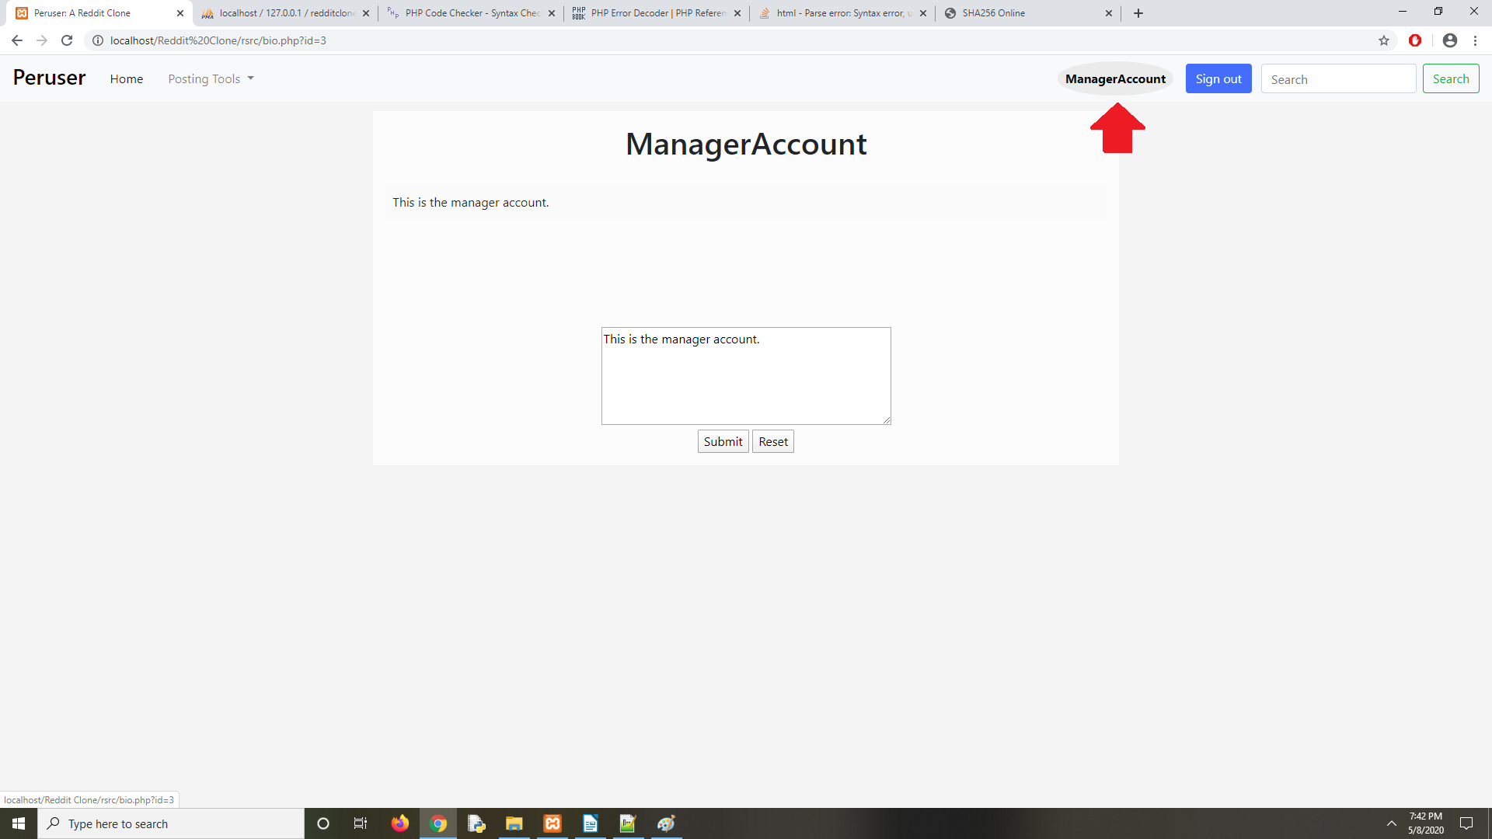

This concludes the project. Thanks for the semester, professor!

Sean Cloyd

